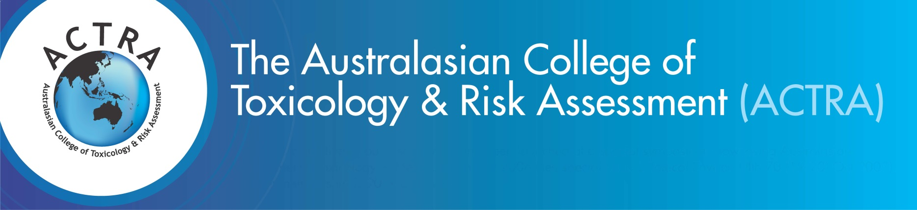
Abstract Submission 2019
Application Form - Closing Date: 21 June 2019
Name ________________________________________________________________________________________
Position ________________________________________________________________________________________
Institution ________________________________________________________________________________________
Address ________________________________________________________________________________________
Contact No _____________________________Email address: ______________________________________________

IMPORTANT - Please ensure all sections of this application are completed
Section 1: Abstract Submission Instructions
Although topics directly related to the ASM theme are preferred, abstracts relating to or dealing with toxicology and/ or risk assessment are most welcome.

- Your abstract submission to the 12th Annual Scientific Meeting (ASM) can be up to one A4 page in length
- Your abstract must not exceed 300 words
- Your abstract must clearly state the objectives and content of your proposed contribution
- Your abstract may include figures, tables, diagrams and illustrations but no photos
- Upon submission, your abstract file must not exceed 2MB
- All abstracts must be submitted in Microsoft word
- All abstracts must adhere to the template formatting requirements (see Abstract template)

Section 2: Checklist
I have completed and attached an abstract which adheres to the requirements above
I have also submitted a project for the Student Travel Grant (please tick if yes)

Section 3: Notification of Acceptance – 12 July 2019
Accepted Abstracts will be allocated a time to orally present their work at the ACTRA ASM after the notification date listed above. Presentation requirements will be sent individually to each presenting individual closer to the ASM date.
Please note
If presenters cannot attend on the day of the ASM due to unforeseen circumstances, the ACTRA ASM Managers must be notified IMMEDIATELY. Abstracts will not be included in the conference proceedings if the authors are not available to present and must not be claimed as a publication by the authors. Please note refunds will not be applicable after the specified dates in the ACTRA ASM cancellation policy. For more information please visit the ACTRA ASM registration page.

Return the completed application form before 21 June 2019 via email to:
ACTRA Conference Managers
Email: actraasm@clems.com.au I Phone: +61 3 9416 3833 I Mobile: +61 423 082 521

